#### **Sprint#3 design:**

In this section, we will introduce the detailed design for the sprint, including the architecture and components among them, and also the database components.

* 1. Component diagram

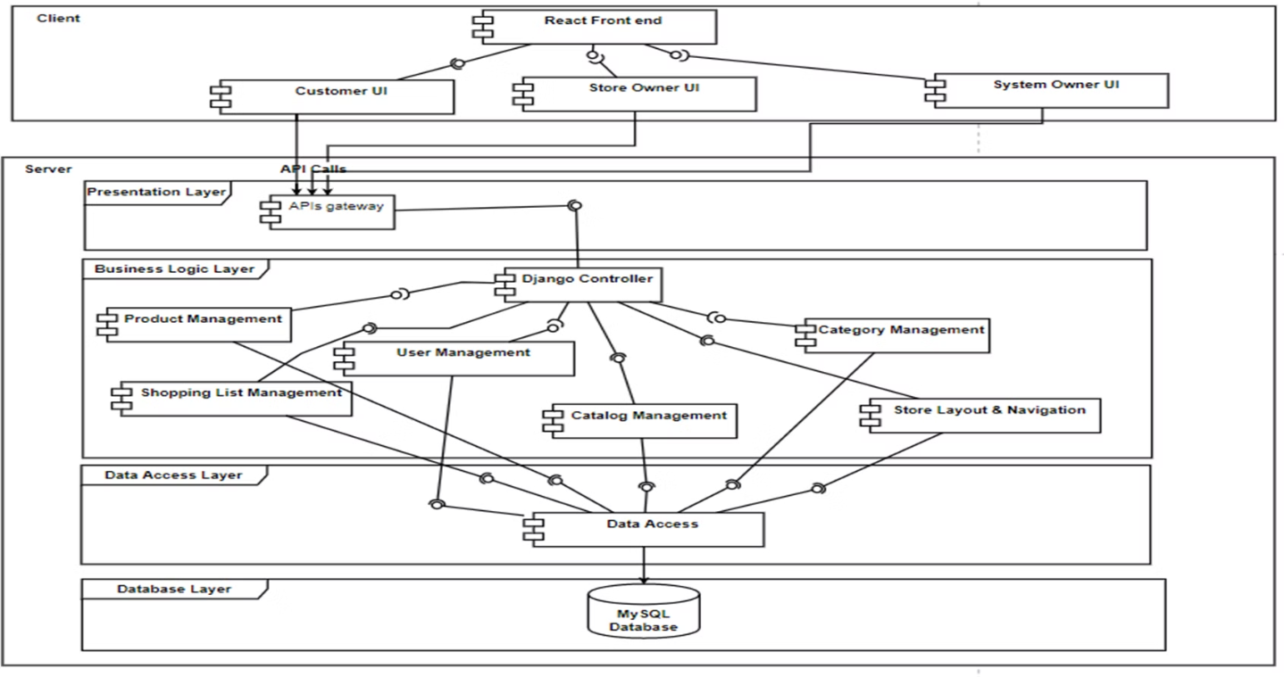

* 1. Detailed class diagram

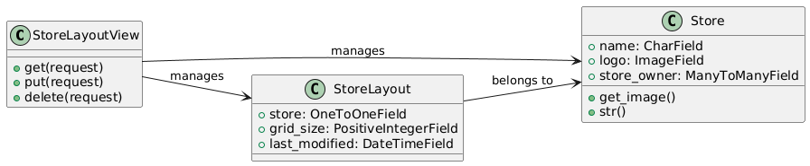

* 1. ER diagram

